Art Workshop
How to Do Portraits in Charcoal
If you would like to learn portrait but afraid to try or don’t know where to begin, this workshop will help take away any fear you may have.

The workshop will teach how to render a representational portrait from life using charcoals, charcoal pencils, white chalk and a few tools. We will learn to observe and see the model, establish a composition, create values, and sketch an accurate head, neck and shoulders.

Saturday and Sunday from 9 to 4PM
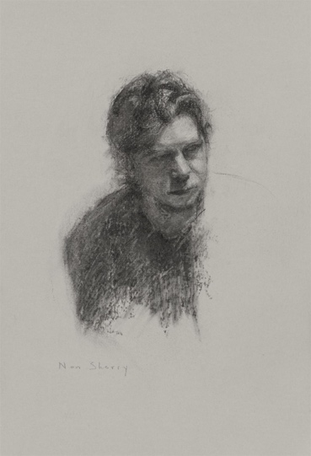
June 18-19, 2022
339 NW US 25-70, Hot Springs, 28743 NC
Teacher Nan Sherry is an artist living in the vibrant town of Marshall, NC where she has a working studio and gallery on Main Street. She paints portrait, figure and landscape and uses oil, pastels, and charcoals to create her art. Nan’s background in the arts spans decades and she is always excited to share her experiences and knowledge with others. Nansherry.com
The Portrait Workshop will be in the comfortable and inspirational Gallery339 Hot Springs, owned by artist Terry Thirion who will assist Nan.
Cost: $250 (does not include materials)
Early bird registration, $10 discount by May 20 Send $100 as a deposit: 704-334-0800

